MRI Brain Scan Classifier Report

Models: ResNet-50, DenseNet-121, EfficientNet-B0

Dataset: Brain MRI Images

Author: [KaiClone](https://github.com/KaiClone)  
Date: 2025

# 1. Introduction

This report presents the results of classifying brain MRI scans into Tumor vs No Tumor categories using three deep learning architectures: ResNet-50, DenseNet-121, and EfficientNet-B0. We include exploratory data analysis (EDA), model evaluation metrics, explainability results, and error analysis.

# 2. Exploratory Data Analysis (EDA)

Class Distribution

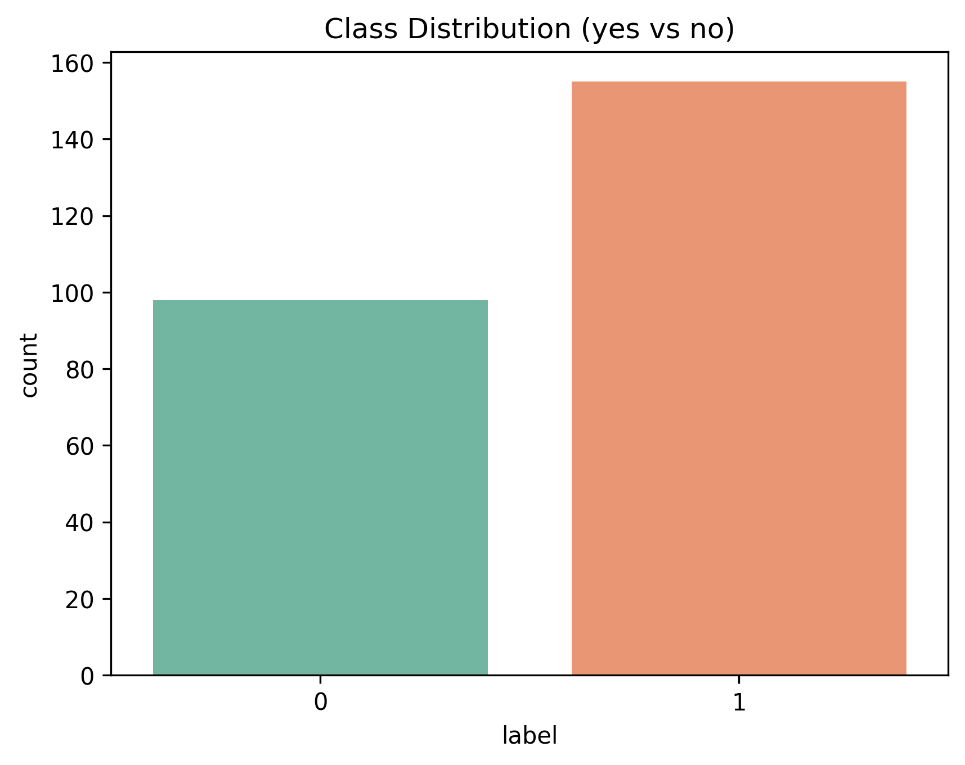

Image Dimensions Distribution

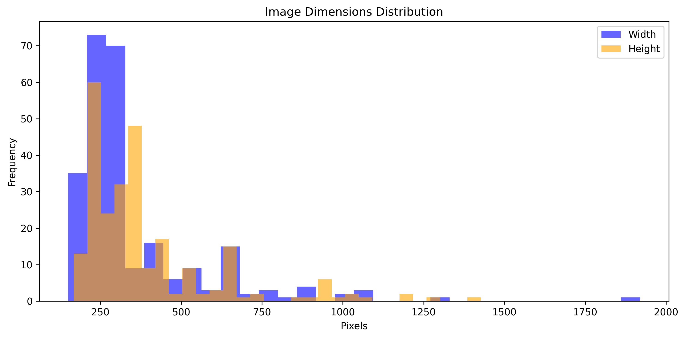

Aspect Ratio Distribution

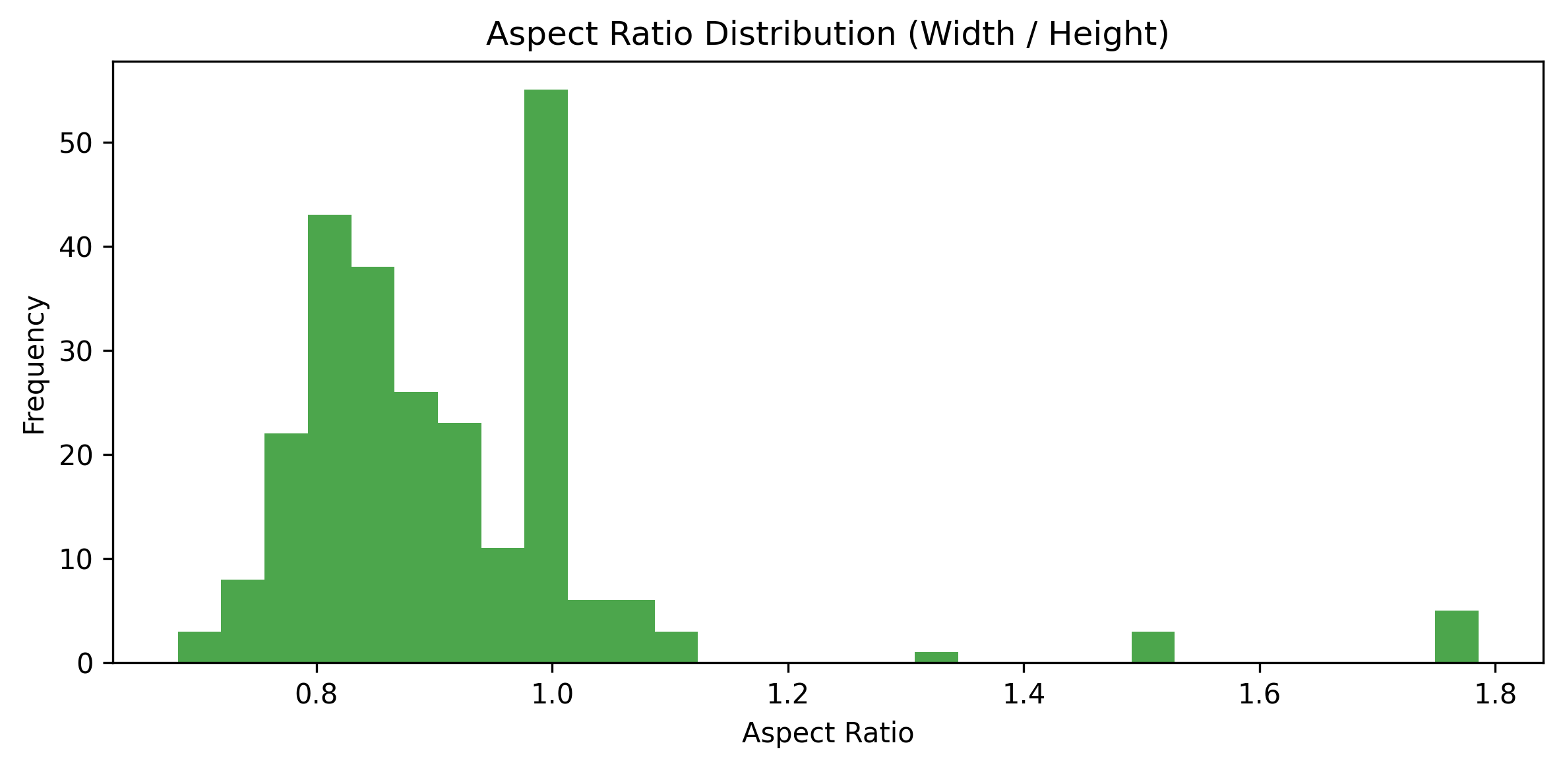

Average Intensity Distribution

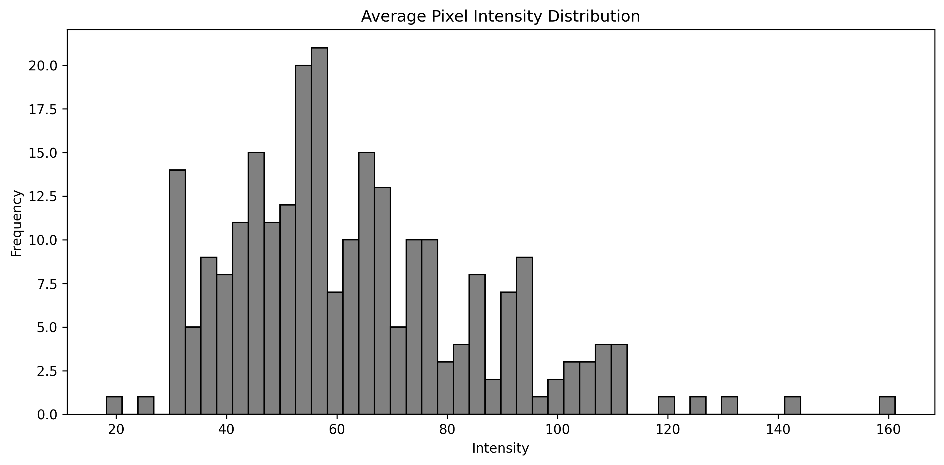

Contrast Distribution By Class

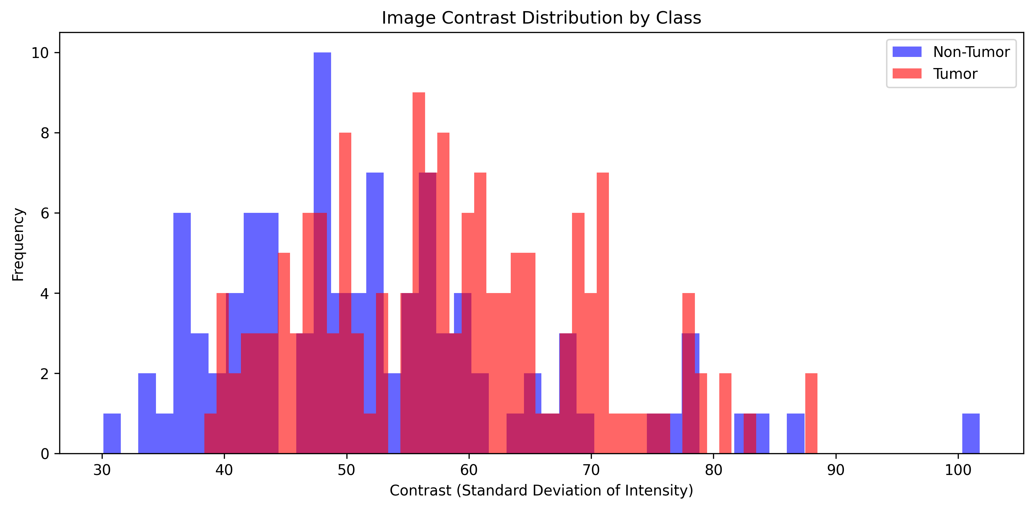

Intensity Distribution By Class

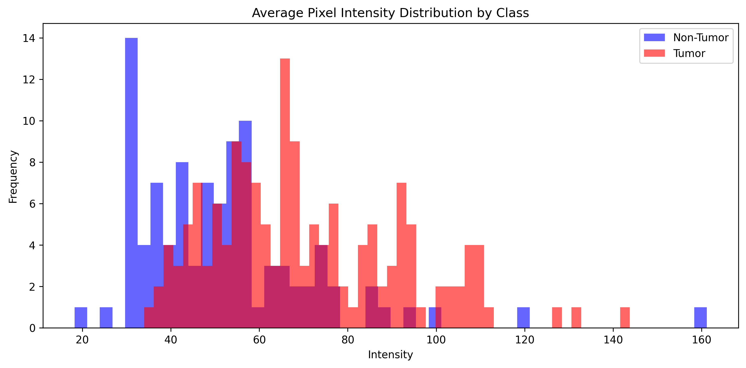

Image Noise Distribution

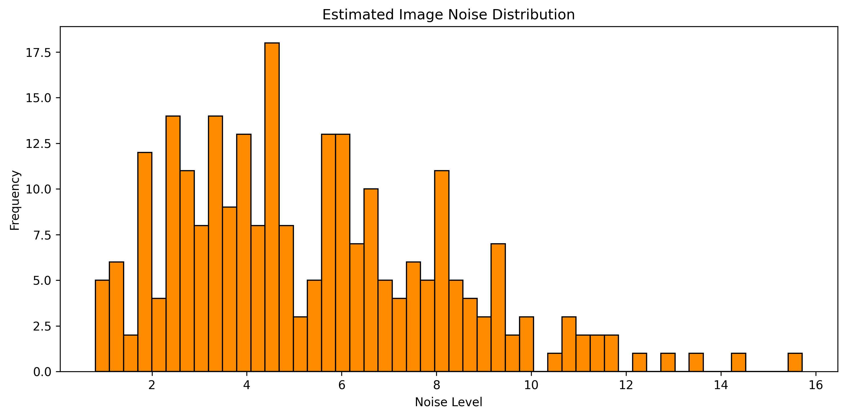

Image Sharpness Distribution

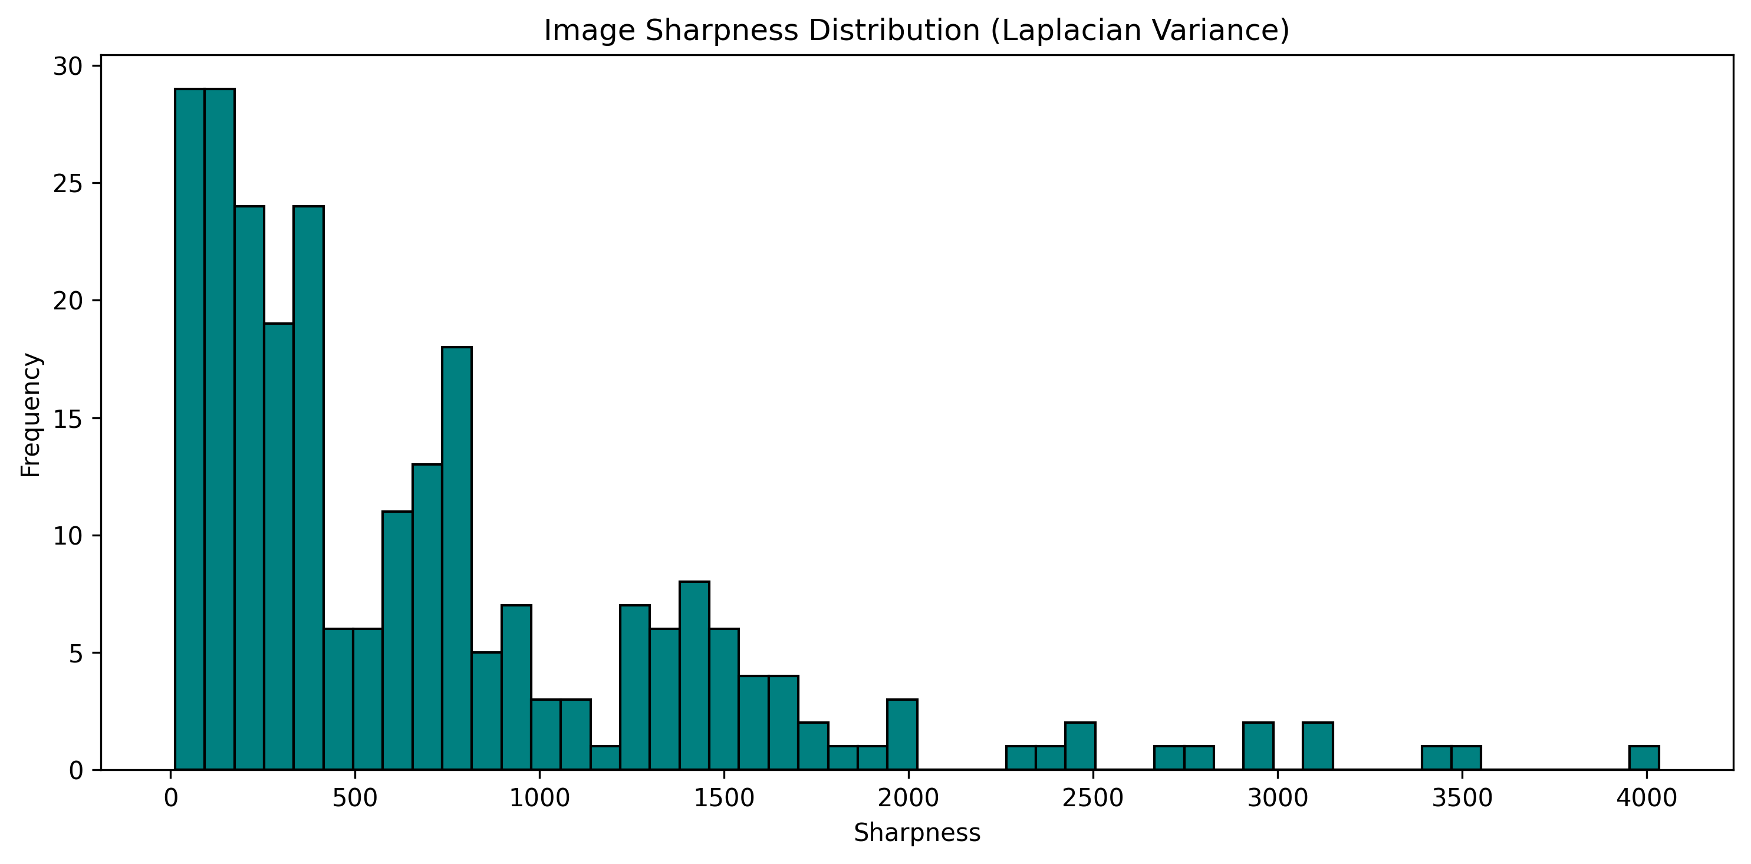

Tsne Projection

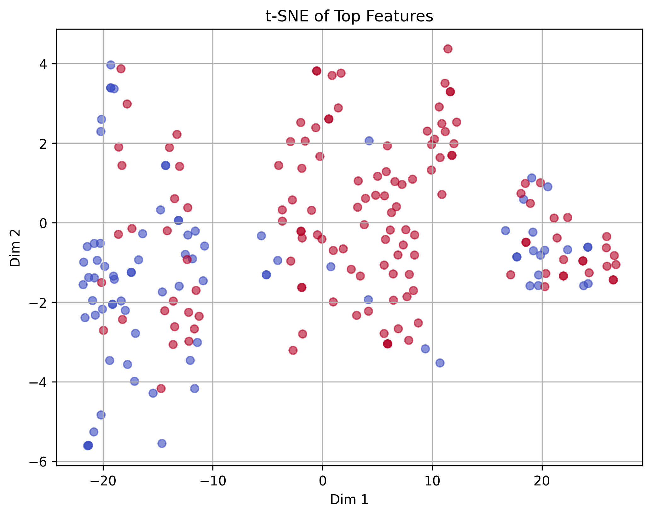

Pca Top 5 Features

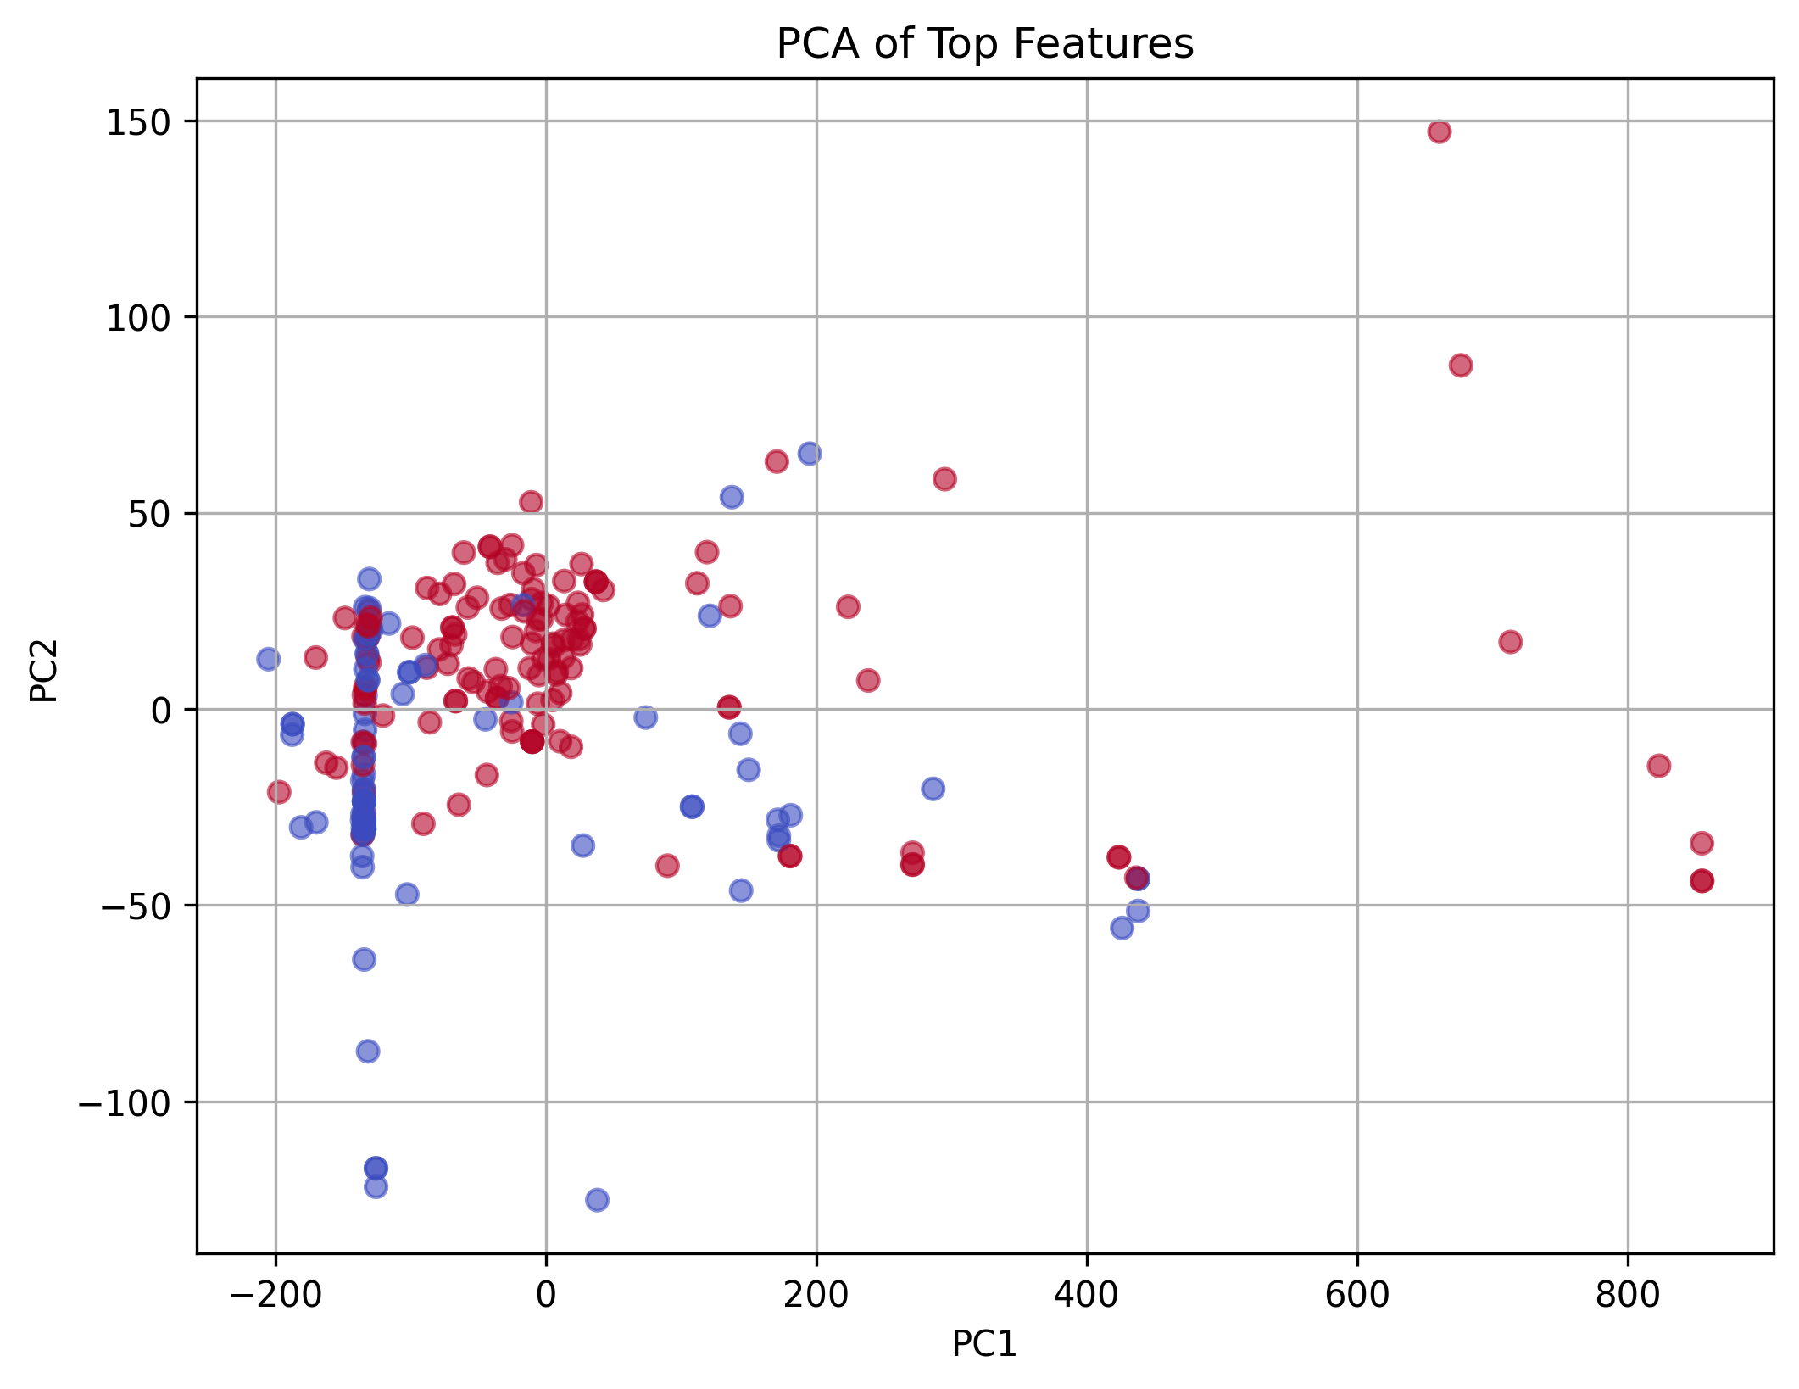

# 3. Model Evaluation – RESNET50

Confusion Matrix:

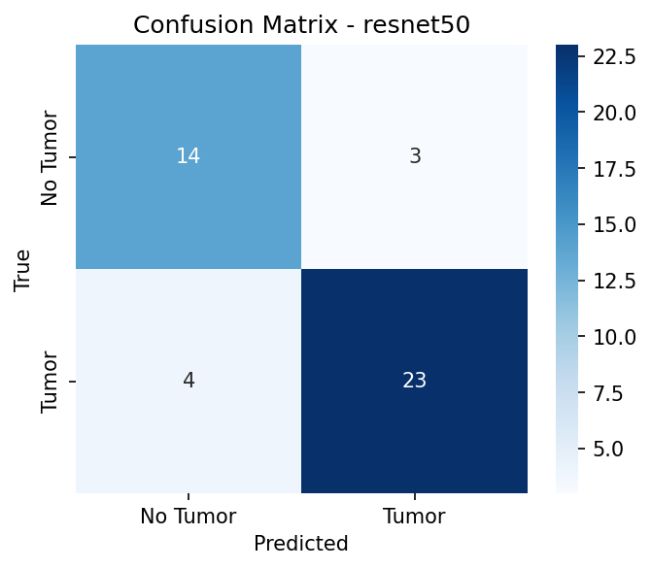

Classification Report:

precision recall f1-score support  
  
 No Tumor 0.78 0.82 0.80 17  
 Tumor 0.88 0.85 0.87 27  
  
 accuracy 0.84 44  
 macro avg 0.83 0.84 0.83 44  
weighted avg 0.84 0.84 0.84 44  
  
  
AUC-ROC Score: 0.9390

Error Analysis (first 10 rows):

|  |  |  |  |  |
| --- | --- | --- | --- | --- |
| filename | path | true_label | pred_label | probability |
| N15.jpg | /kaggle/input/brain-mri-images-for-brain-tumor-detection/brain_tumor_dataset/no/N15.jpg | 0 | 0 | 0.3932501673698425 |
| Y180.jpg | /kaggle/input/brain-mri-images-for-brain-tumor-detection/brain_tumor_dataset/yes/Y180.jpg | 1 | 1 | 0.9959118366241456 |
| Y155.JPG | /kaggle/input/brain-mri-images-for-brain-tumor-detection/brain_tumor_dataset/yes/Y155.JPG | 1 | 1 | 0.9752045273780824 |
| N3.jpg | /kaggle/input/brain-mri-images-for-brain-tumor-detection/brain_tumor_dataset/no/N3.jpg | 0 | 0 | 0.0329466052353382 |
| Y99.JPG | /kaggle/input/brain-mri-images-for-brain-tumor-detection/brain_tumor_dataset/yes/Y99.JPG | 1 | 1 | 0.7801456451416016 |
| N19.JPG | /kaggle/input/brain-mri-images-for-brain-tumor-detection/brain_tumor_dataset/no/N19.JPG | 0 | 1 | 0.6424224972724915 |
| Y73.jpg | /kaggle/input/brain-mri-images-for-brain-tumor-detection/brain_tumor_dataset/yes/Y73.jpg | 1 | 1 | 0.5742194056510925 |
| Y79.jpg | /kaggle/input/brain-mri-images-for-brain-tumor-detection/brain_tumor_dataset/yes/Y79.jpg | 1 | 1 | 0.9786039590835572 |
| 24 no.jpg | /kaggle/input/brain-mri-images-for-brain-tumor-detection/brain_tumor_dataset/no/24 no.jpg | 0 | 0 | 0.1353213936090469 |
| Y38.jpg | /kaggle/input/brain-mri-images-for-brain-tumor-detection/brain_tumor_dataset/yes/Y38.jpg | 1 | 1 | 0.9559105038642884 |

# 3. Model Evaluation – DENSENET121

Confusion Matrix:

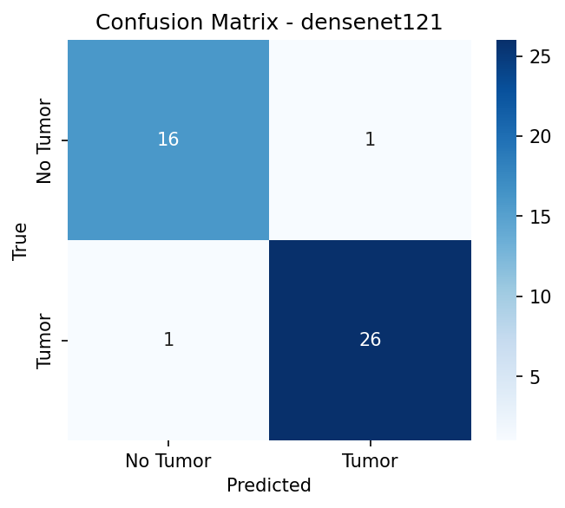

Classification Report:

precision recall f1-score support  
  
 No Tumor 0.94 0.94 0.94 17  
 Tumor 0.96 0.96 0.96 27  
  
 accuracy 0.95 44  
 macro avg 0.95 0.95 0.95 44  
weighted avg 0.95 0.95 0.95 44  
  
  
AUC-ROC Score: 0.9826

Error Analysis (first 10 rows):

|  |  |  |  |  |
| --- | --- | --- | --- | --- |
| filename | path | true_label | pred_label | probability |
| N15.jpg | /kaggle/input/brain-mri-images-for-brain-tumor-detection/brain_tumor_dataset/no/N15.jpg | 0 | 1 | 0.6776241660118103 |
| Y180.jpg | /kaggle/input/brain-mri-images-for-brain-tumor-detection/brain_tumor_dataset/yes/Y180.jpg | 1 | 1 | 0.99912828207016 |
| Y155.JPG | /kaggle/input/brain-mri-images-for-brain-tumor-detection/brain_tumor_dataset/yes/Y155.JPG | 1 | 1 | 0.9958581328392028 |
| N3.jpg | /kaggle/input/brain-mri-images-for-brain-tumor-detection/brain_tumor_dataset/no/N3.jpg | 0 | 0 | 0.0076405322179198 |
| Y99.JPG | /kaggle/input/brain-mri-images-for-brain-tumor-detection/brain_tumor_dataset/yes/Y99.JPG | 1 | 1 | 0.9698885679244996 |
| N19.JPG | /kaggle/input/brain-mri-images-for-brain-tumor-detection/brain_tumor_dataset/no/N19.JPG | 0 | 0 | 0.3967544138431549 |
| Y73.jpg | /kaggle/input/brain-mri-images-for-brain-tumor-detection/brain_tumor_dataset/yes/Y73.jpg | 1 | 1 | 0.9103199243545532 |
| Y79.jpg | /kaggle/input/brain-mri-images-for-brain-tumor-detection/brain_tumor_dataset/yes/Y79.jpg | 1 | 1 | 0.9877227544784546 |
| 24 no.jpg | /kaggle/input/brain-mri-images-for-brain-tumor-detection/brain_tumor_dataset/no/24 no.jpg | 0 | 0 | 0.0584124028682708 |
| Y38.jpg | /kaggle/input/brain-mri-images-for-brain-tumor-detection/brain_tumor_dataset/yes/Y38.jpg | 1 | 1 | 0.9861374497413636 |

# 3. Model Evaluation – EFFICIENTNET_B0

Confusion Matrix:

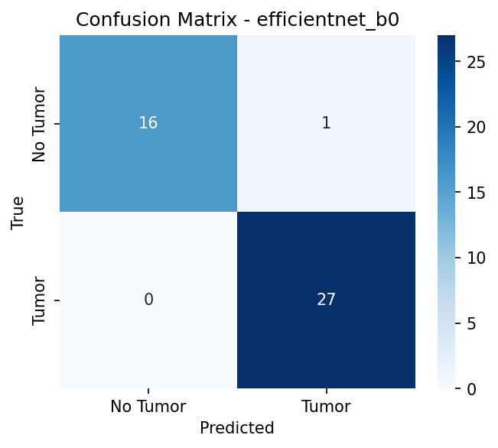

Classification Report:

precision recall f1-score support  
  
 No Tumor 1.00 0.94 0.97 17  
 Tumor 0.96 1.00 0.98 27  
  
 accuracy 0.98 44  
 macro avg 0.98 0.97 0.98 44  
weighted avg 0.98 0.98 0.98 44  
  
  
AUC-ROC Score: 1.0000

Error Analysis (first 10 rows):

|  |  |  |  |  |
| --- | --- | --- | --- | --- |
| filename | path | true_label | pred_label | probability |
| N15.jpg | /kaggle/input/brain-mri-images-for-brain-tumor-detection/brain_tumor_dataset/no/N15.jpg | 0 | 0 | 0.3897193670272827 |
| Y180.jpg | /kaggle/input/brain-mri-images-for-brain-tumor-detection/brain_tumor_dataset/yes/Y180.jpg | 1 | 1 | 0.9863893389701844 |
| Y155.JPG | /kaggle/input/brain-mri-images-for-brain-tumor-detection/brain_tumor_dataset/yes/Y155.JPG | 1 | 1 | 0.9988676309585572 |
| N3.jpg | /kaggle/input/brain-mri-images-for-brain-tumor-detection/brain_tumor_dataset/no/N3.jpg | 0 | 0 | 0.0005333978915587 |
| Y99.JPG | /kaggle/input/brain-mri-images-for-brain-tumor-detection/brain_tumor_dataset/yes/Y99.JPG | 1 | 1 | 0.992849826812744 |
| N19.JPG | /kaggle/input/brain-mri-images-for-brain-tumor-detection/brain_tumor_dataset/no/N19.JPG | 0 | 1 | 0.5555327534675598 |
| Y73.jpg | /kaggle/input/brain-mri-images-for-brain-tumor-detection/brain_tumor_dataset/yes/Y73.jpg | 1 | 1 | 0.9884159564971924 |
| Y79.jpg | /kaggle/input/brain-mri-images-for-brain-tumor-detection/brain_tumor_dataset/yes/Y79.jpg | 1 | 1 | 0.9921966791152954 |
| 24 no.jpg | /kaggle/input/brain-mri-images-for-brain-tumor-detection/brain_tumor_dataset/no/24 no.jpg | 0 | 0 | 0.0342348888516426 |
| Y38.jpg | /kaggle/input/brain-mri-images-for-brain-tumor-detection/brain_tumor_dataset/yes/Y38.jpg | 1 | 1 | 0.9957278966903688 |

# 4. Explainability (Grad-CAM & Integrated Gradients)

## RESNET50

Gradcam++

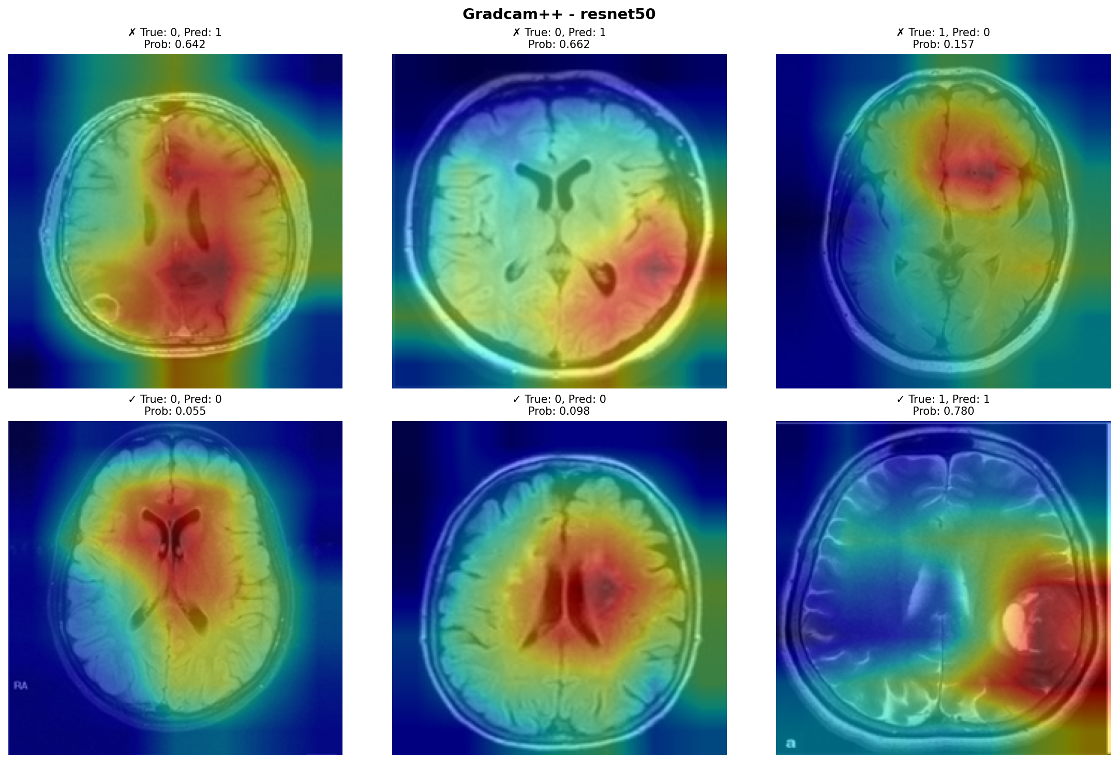

Figure: Grad-CAM++ visualization for RESNET50

Integrated Gradients

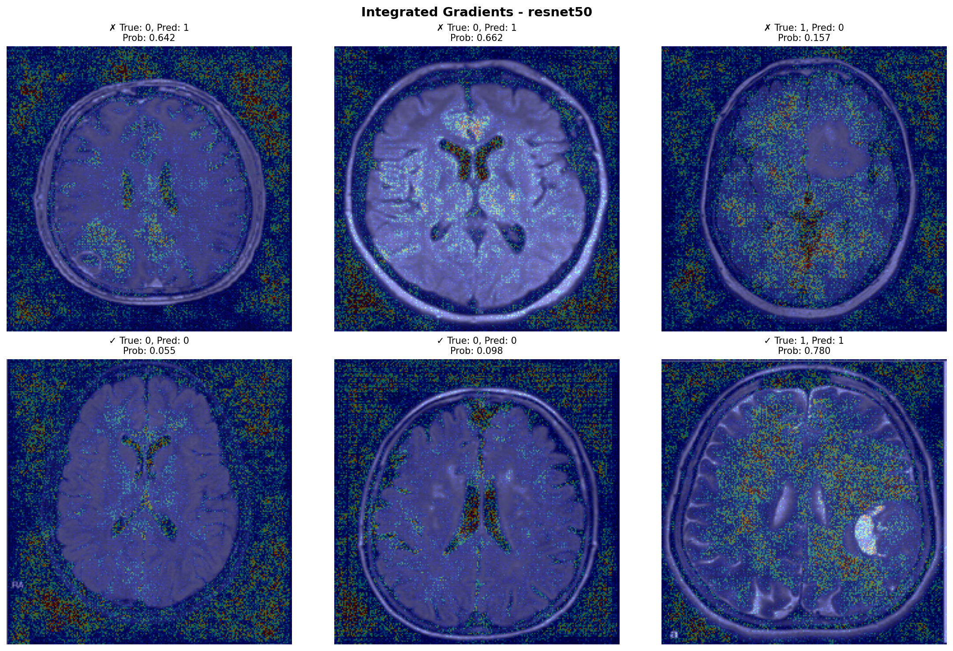

Figure: Integrated Gradients visualization for RESNET50

## DENSENET121

Gradcam++

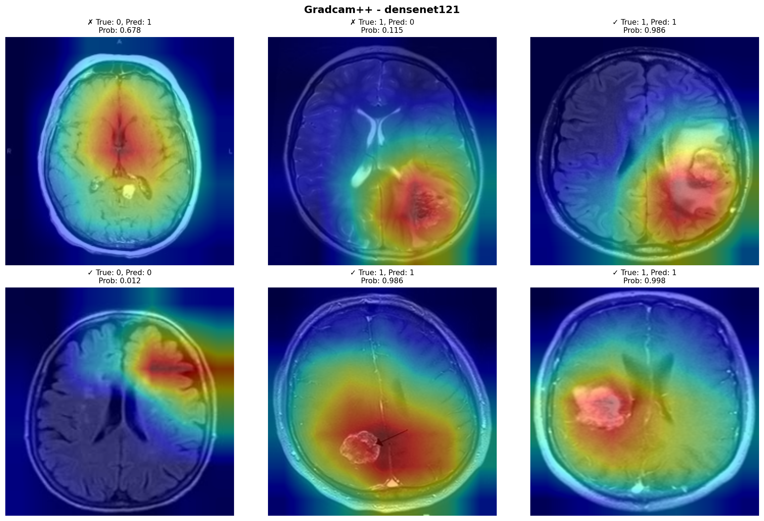

Figure: Grad-CAM++ visualization for DENSENET121

Integrated Gradients

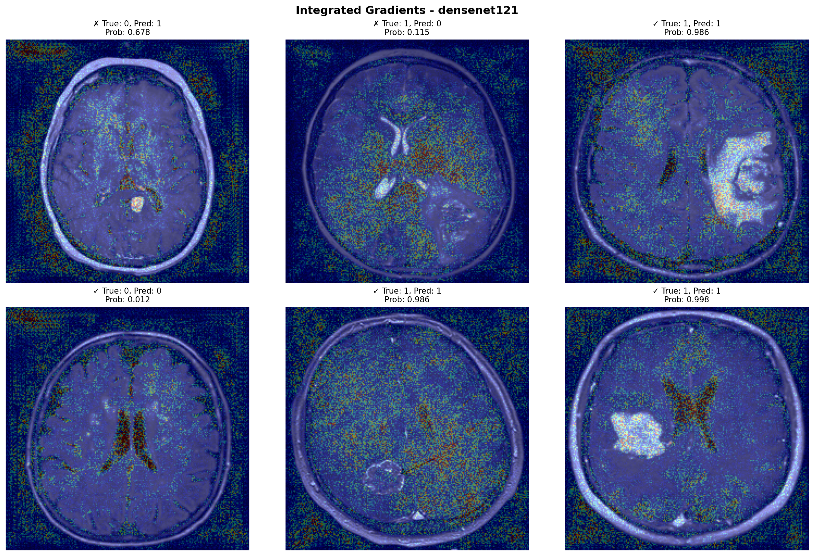

Figure: Integrated Gradients visualization for DENSENET121

## EFFICIENTNET_B0

Gradcam++

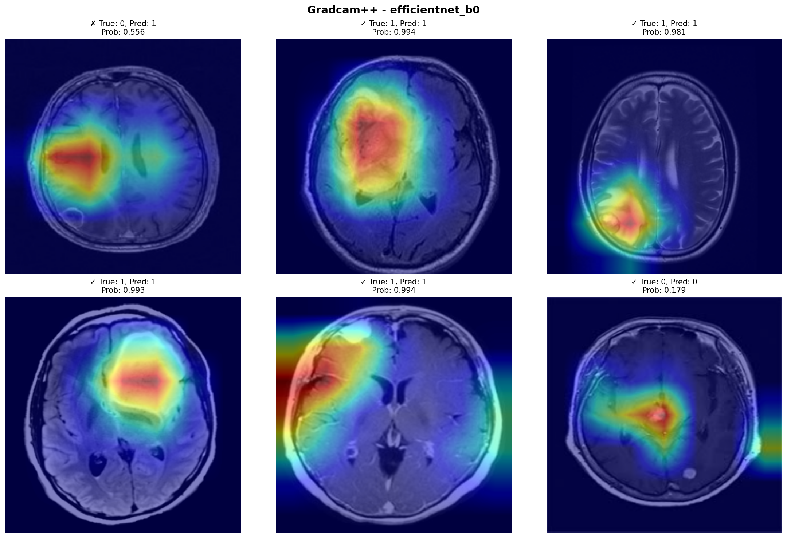

Figure: Grad-CAM++ visualization for EFFICIENTNET_B0

Integrated Gradients

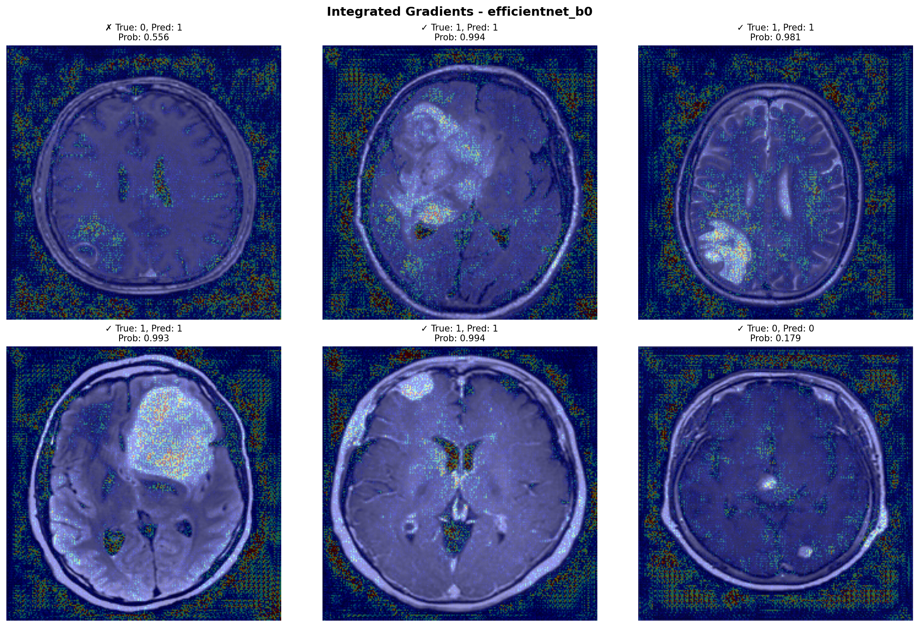

Figure: Integrated Gradients visualization for EFFICIENTNET_B0

# 5. Model Comparison

# 6. Conclusion

EfficientNet-B0 achieved the highest accuracy (97.7%) and perfect AUC (1.0), outperforming ResNet-50 and DenseNet-121. Explainability methods such as Grad-CAM++ and Integrated Gradients confirm that the models focus on relevant tumor regions. This system demonstrates high reliability in brain tumor detection, but future work should include multi-class classification and external validation.